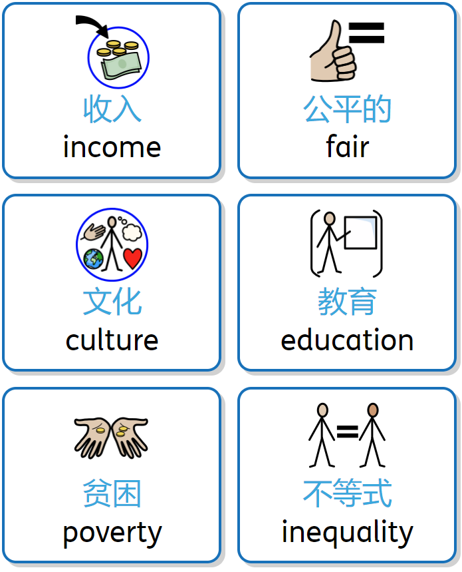
L1 Reflection on Dollar Street

Type your answers below each question
- What is income inequality (收入不平等), and why should we learn about it?

- Did you notice families on Dollar Street with different amounts of money (钱)? How were their lives different, and what does this teach us?

- Why do some people have more money (钱) than others, even if they are from the same country (国家)?

- Why is it important to help people who have less money (钱) than us, and how can we make the world (世界) more fair (公平) for everyone?

- How can we make sure everyone has enough money (钱) to live well, no matter where they're from (来自哪里) or what they look like (长什么样)?

- Why is education (教育) important when talking about money (钱) and income (收入)?

- What shows that poverty (贫穷) is more about how much money (钱) people have, not where they come from (来自哪里)?

