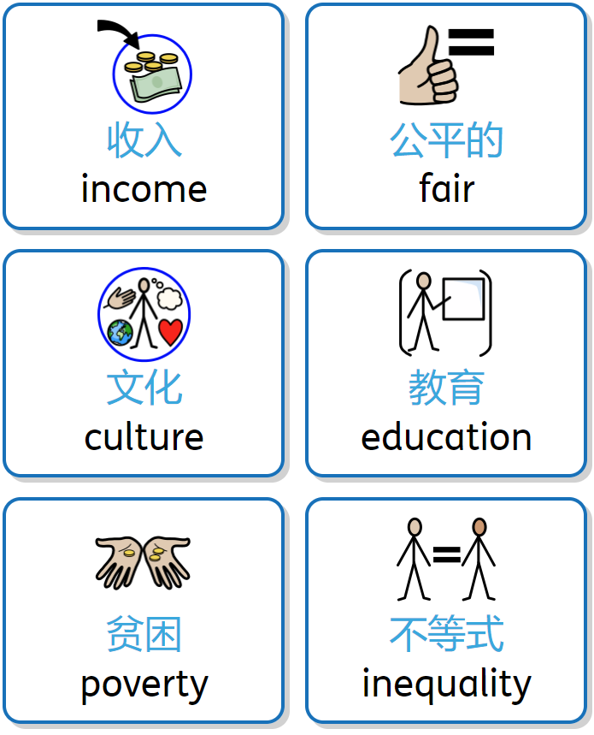
L2 Reflection on Dollar Street
Type your answers below each question
- What is income inequality, and why should we learn about it?

- Did you notice families on Dollar Street with different amounts of money? How were their lives different, and what does this teach us?

- Why do some people have more money than others, even if they are from the same country?

- Why is it important to help people who have less money than us, and how can we eliminate inequality for everyone?

- How can we make sure everyone has enough money to live well, no matter where they're
from or what they look like?

- Why is education important when talking about money and income?

- What shows that poverty is more about how much money people have, not where they
come from?

